# CSN ASSIGNMENT 2B

Website Link: [scottwcfe.github.io](https://scottwcfe.github.io)

Scott Mitchell

CSN 2024/25

Development Choices:

I chose to mainly use external CSS as its easier for me to understand where all the specific style choices take place in the code.

I used a specific naming scheme for the classes, for example to centre images named the class, .centre_home for centring images on the home page and .centre_history for the history page.

I decided to only do 8-9 pages as I have not completed the game fully yet, I was hoping to get a 100% play through finished, but it was unrealistic with the timeline given for this project, the other pages would mainly be centred around the story and how it effects the main character and side characters.

Testing:

User:

Home page button a bit too blue. Contact page everything aligned too far to left. A bit more text to round out the page. Order of pages on dropdown was incorrect (fixed this).

Developer:

From my own testing I have noticed the problems listed by the user, but I couldn’t find anyway to break my website completely. I did notice sometimes the images did not load properly so I just had to reset the page.

Browser Test:

Website was made and checked during development using opera gx which runs on an older version of chromes search engine, I did the browser test on Microsoft Edge as I am not very familiar with.

Original UI Design:

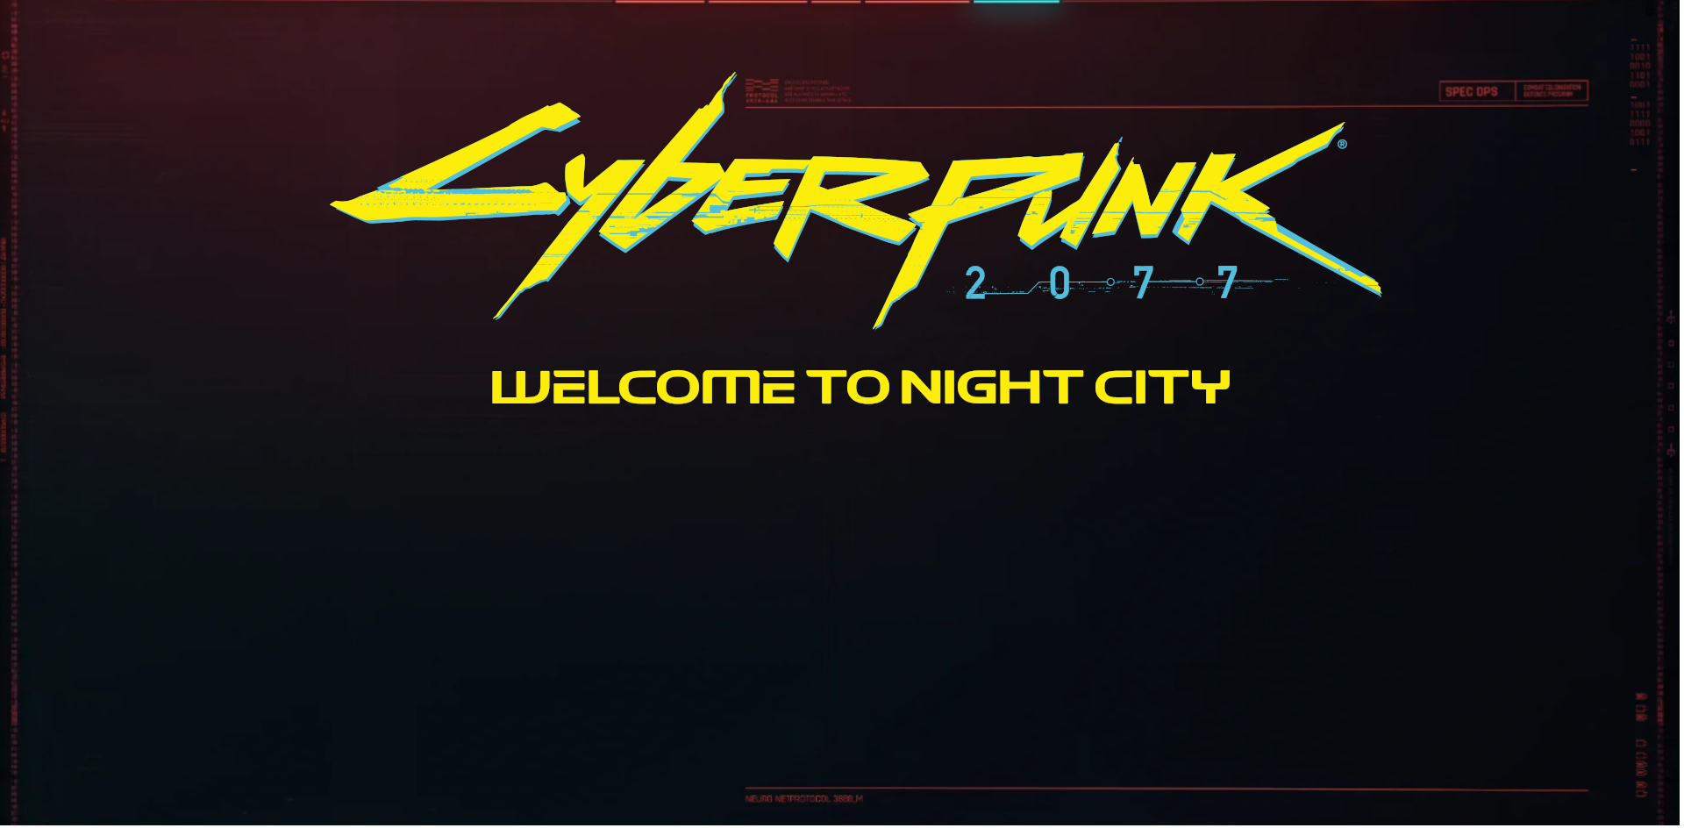

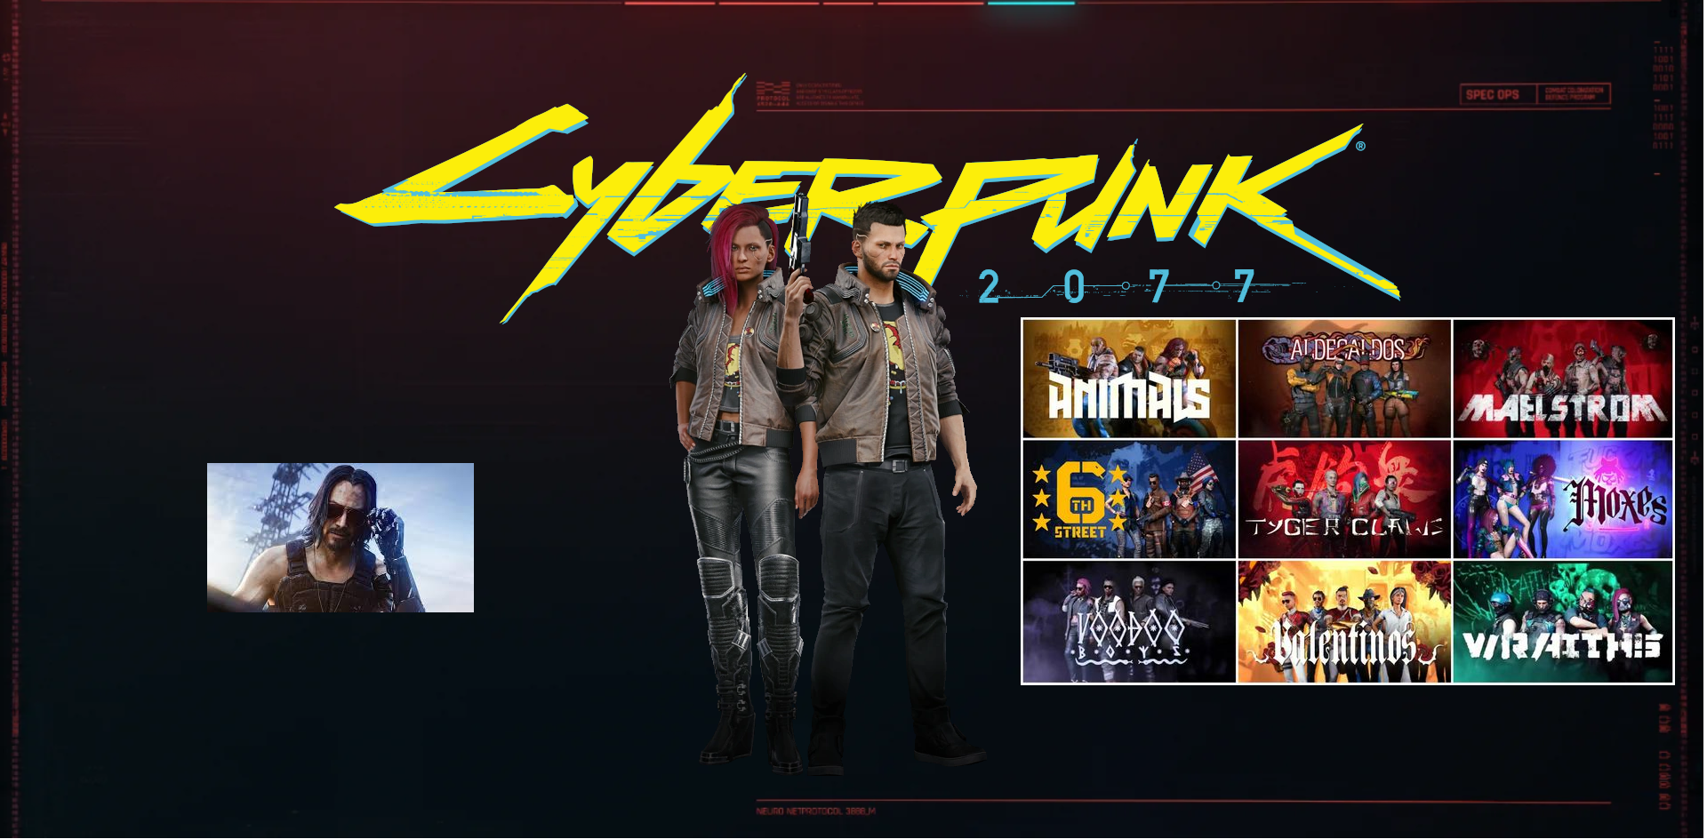



New UI Design:

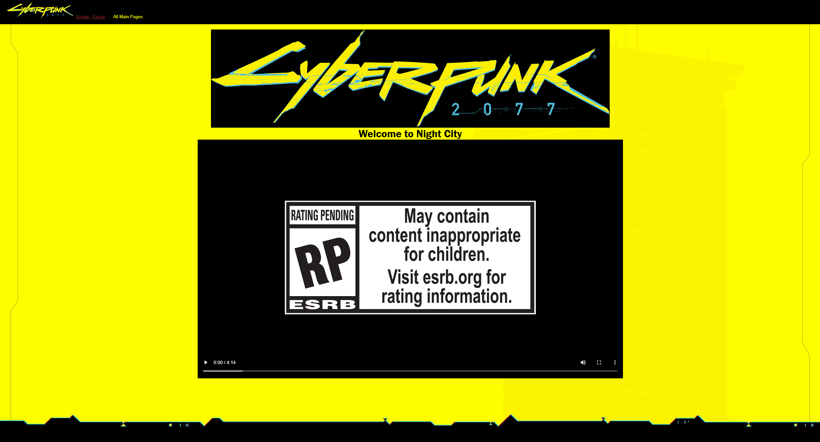

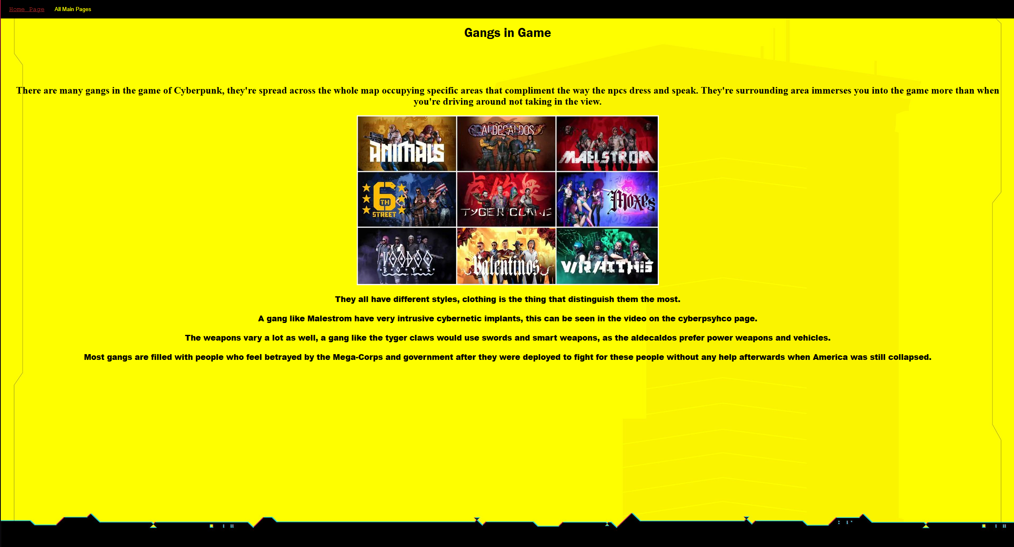

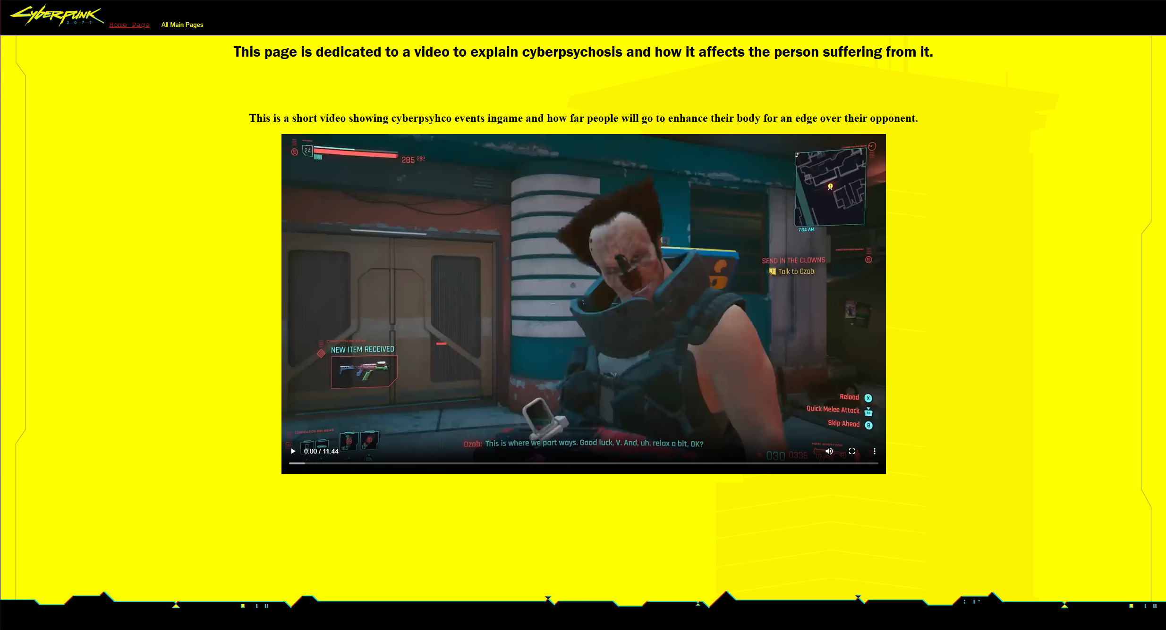

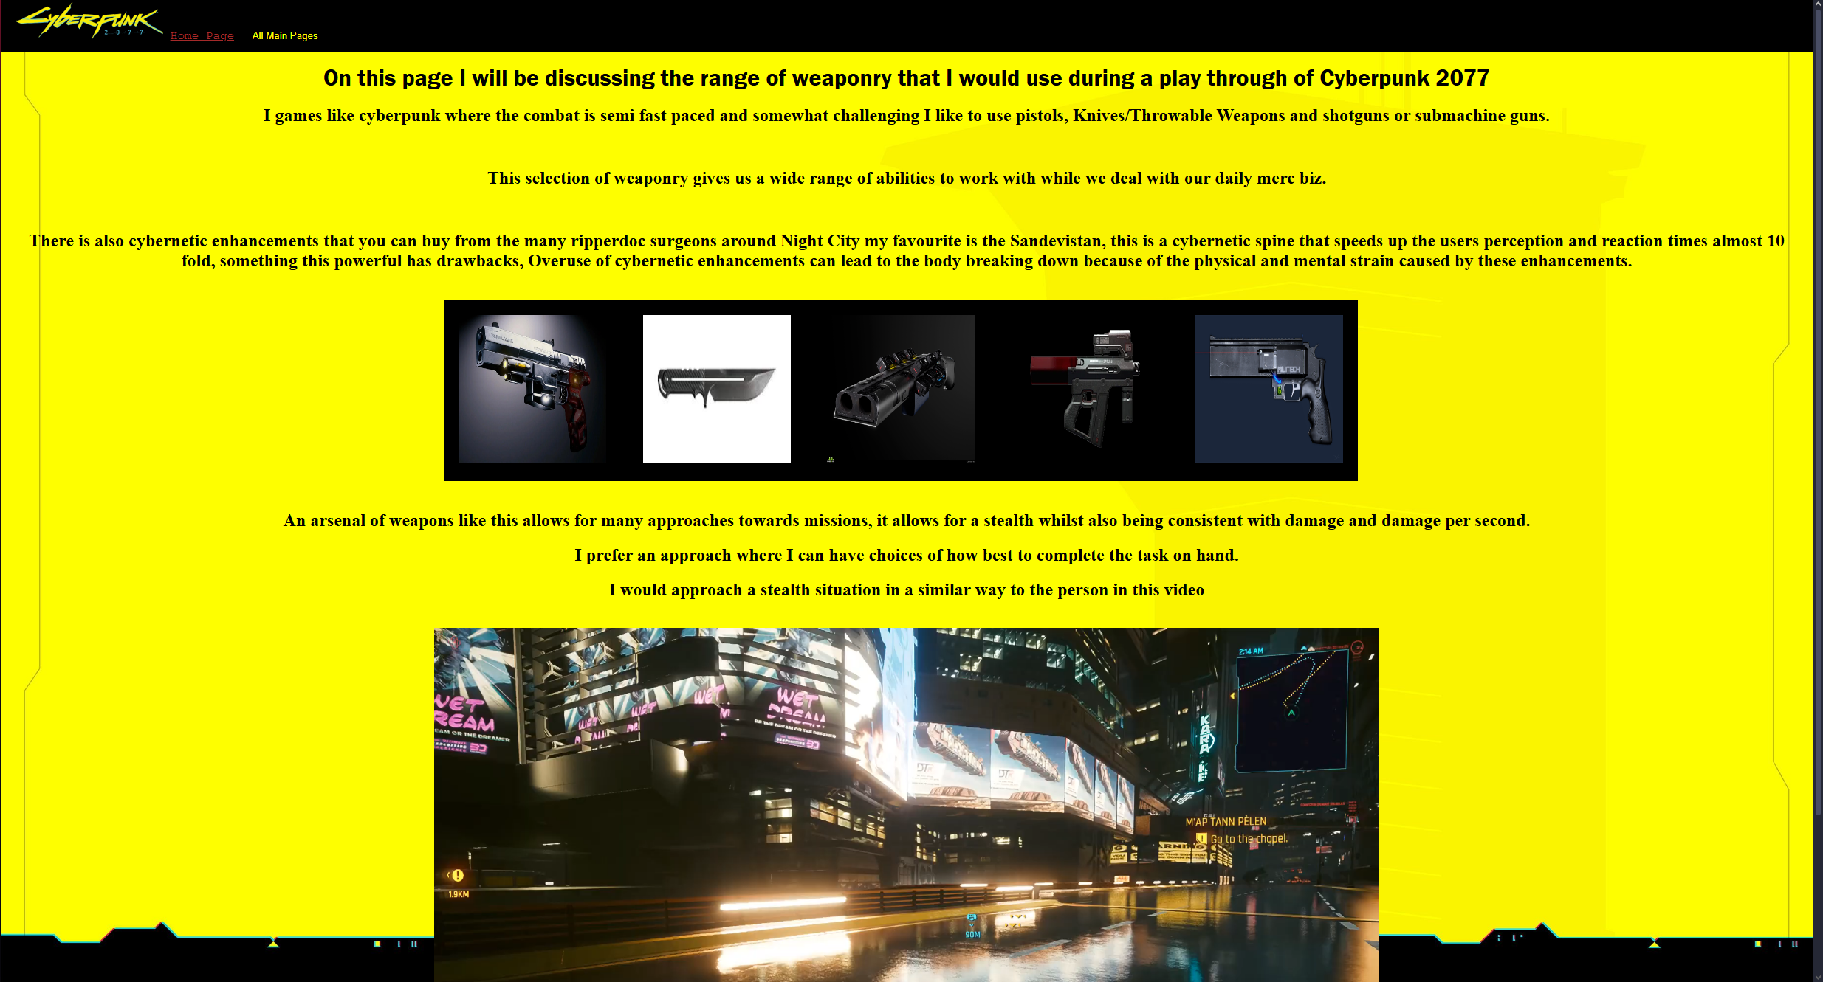

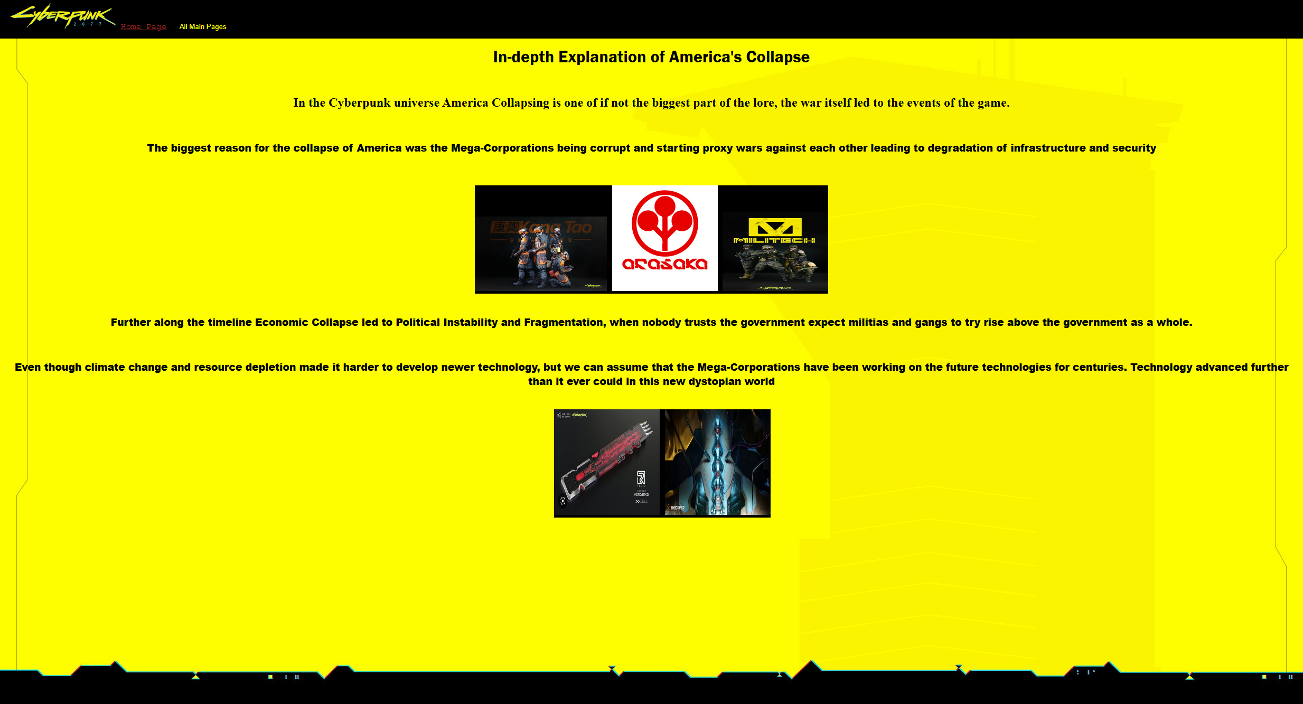

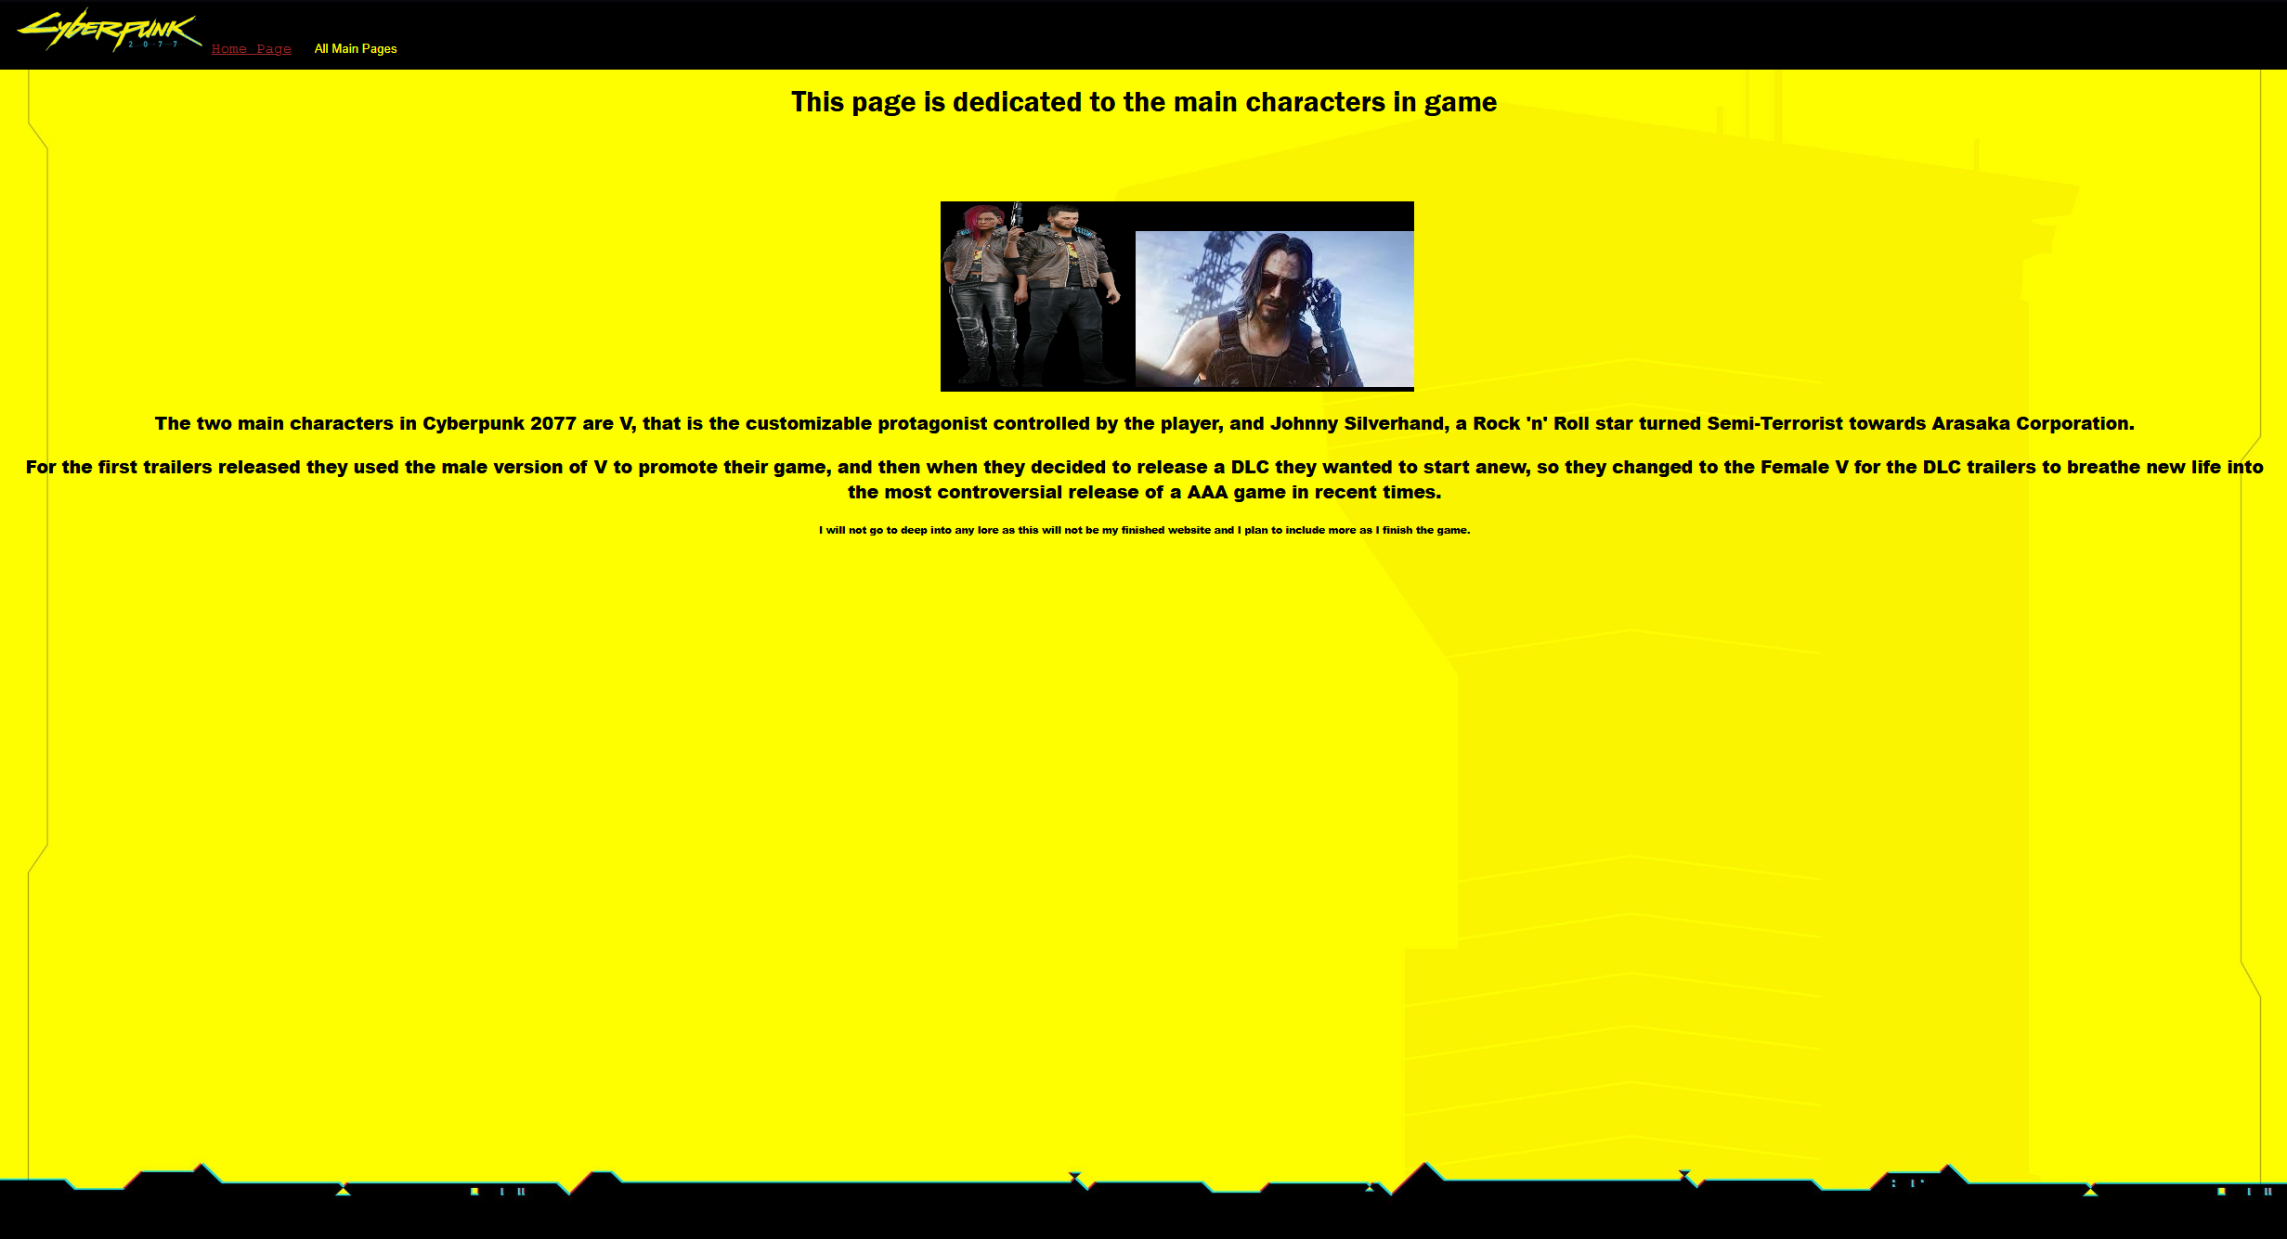

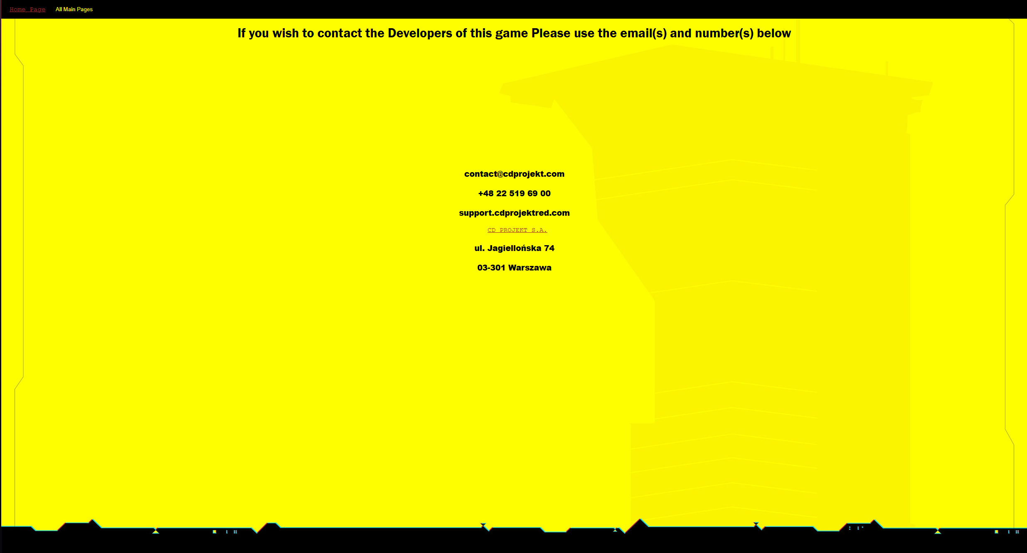

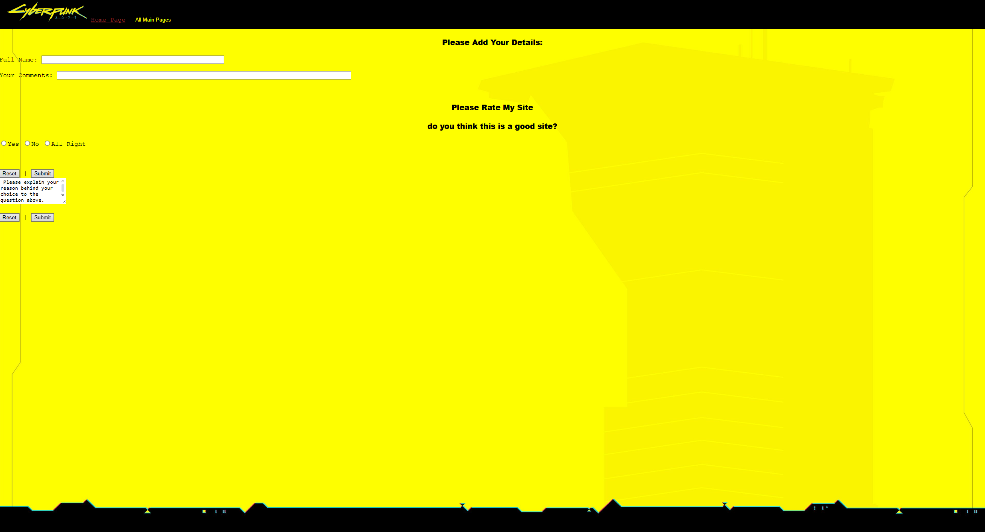

HTML Code:

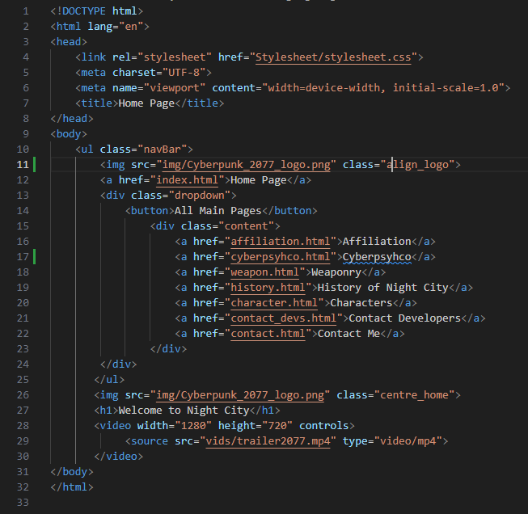

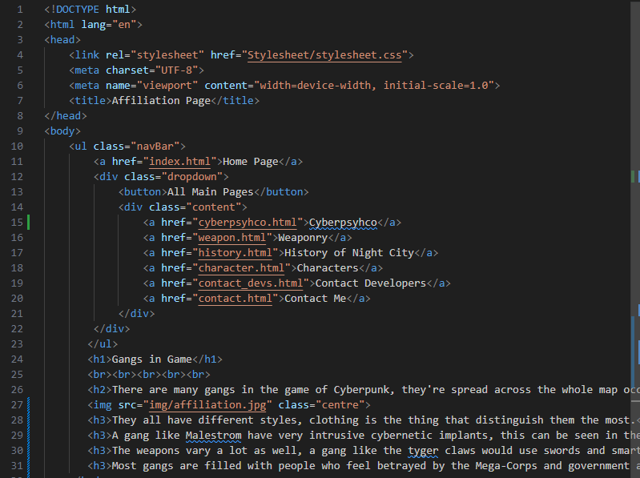

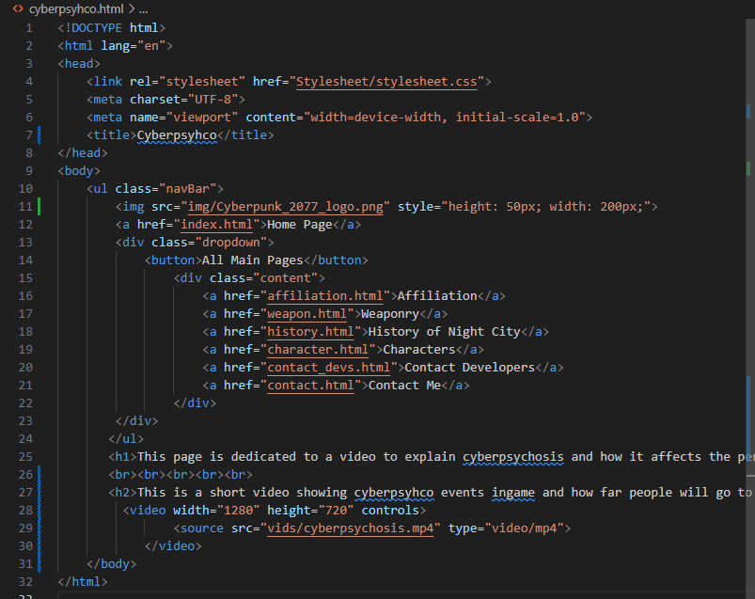

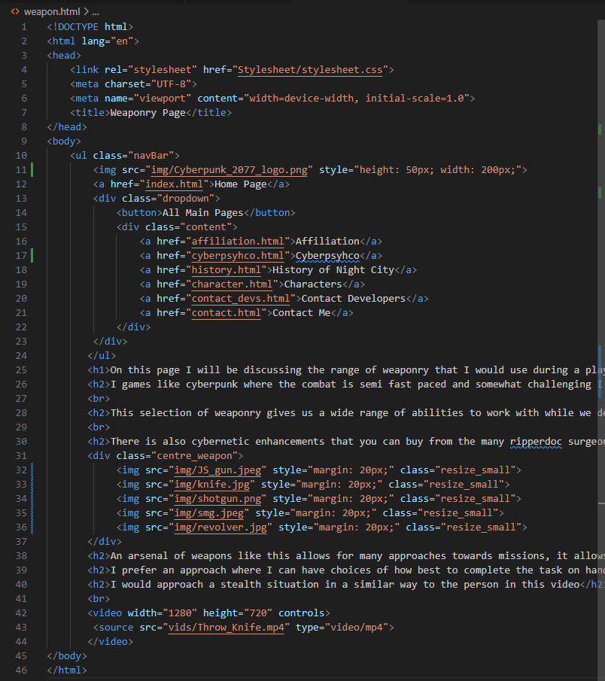

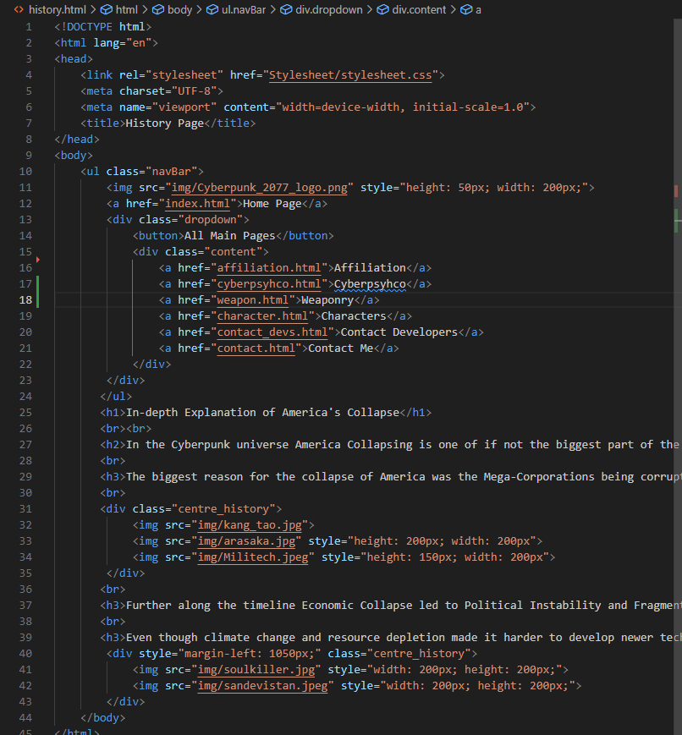

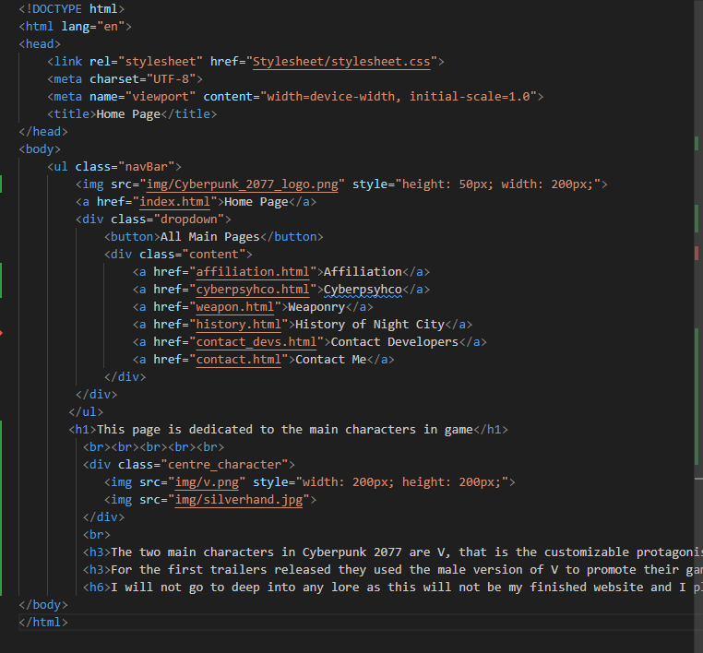

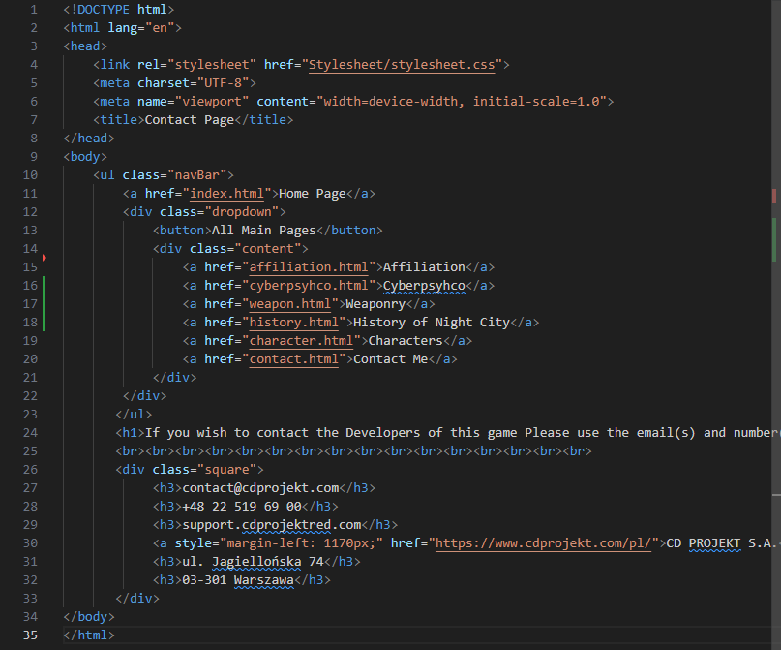

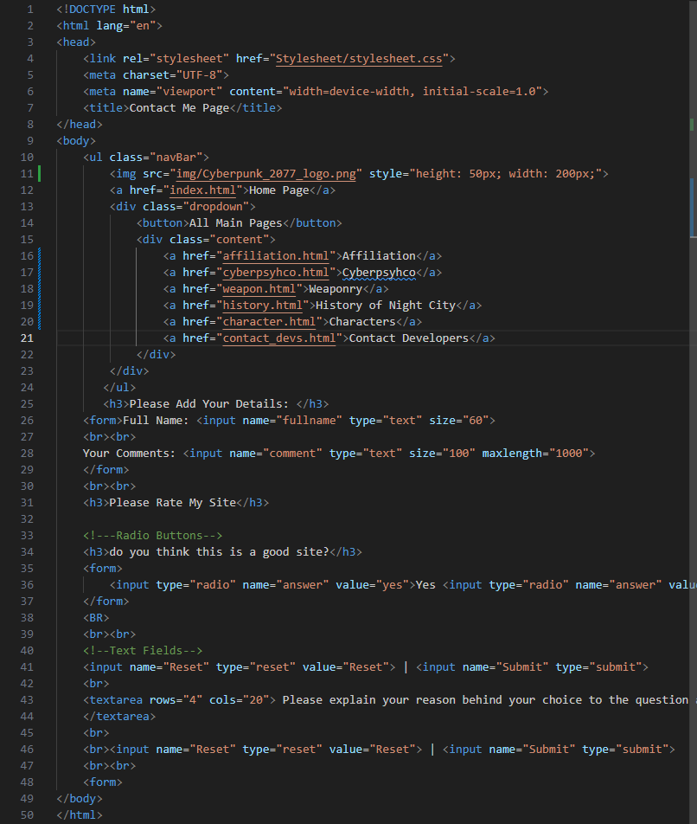

External CSS Code:

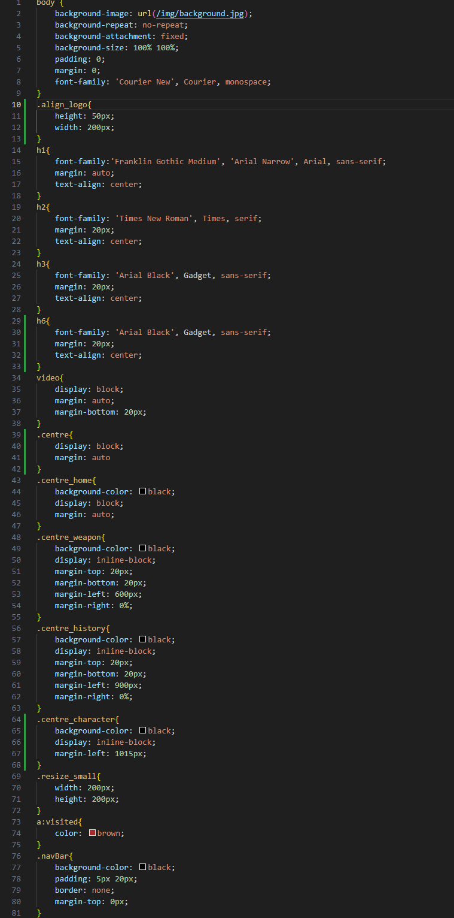

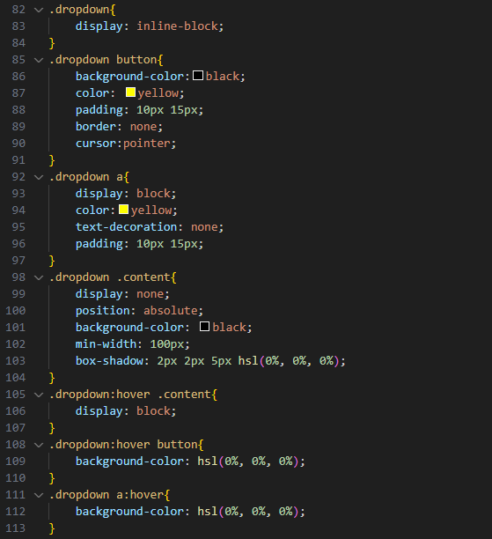

Uploading to Github:

Uploading your website is to github is as simple:

1. Create an account.
2. Create a repository named as “user_name.github.io” replacing user_name with your own username, it is case-sensitive.
3. Make sure your main page is named index.html, this is also case-sensitive.
4. It might take a few minutes before your website is fully uploaded and updated so stay patient.